计算班级花费余额
#include <iostream>
using namespace std;
class TSstudent
{
public:
double money;
static double m_ClassMoney;
void InitStudent()
{
}
void ExpendMoney(double a)
{
money = a;
}
double ShowMoney()
{
m_ClassMoney = m_ClassMoney - money;
return m_ClassMoney;
}
};
double TSstudent::m_ClassMoney = 1000;
int main()
{
TSstudent A;
TSstudent B;
TSstudent C;
A.ExpendMoney(50);
cout << "班费还剩余" << A.ShowMoney() << endl;
B.ExpendMoney(98.5);
cout << "班费还剩余" << B.ShowMoney() << endl;
C.ExpendMoney(500.53);
cout << "班费还剩余" << C.ShowMoney() << endl;}

结果是下面的图
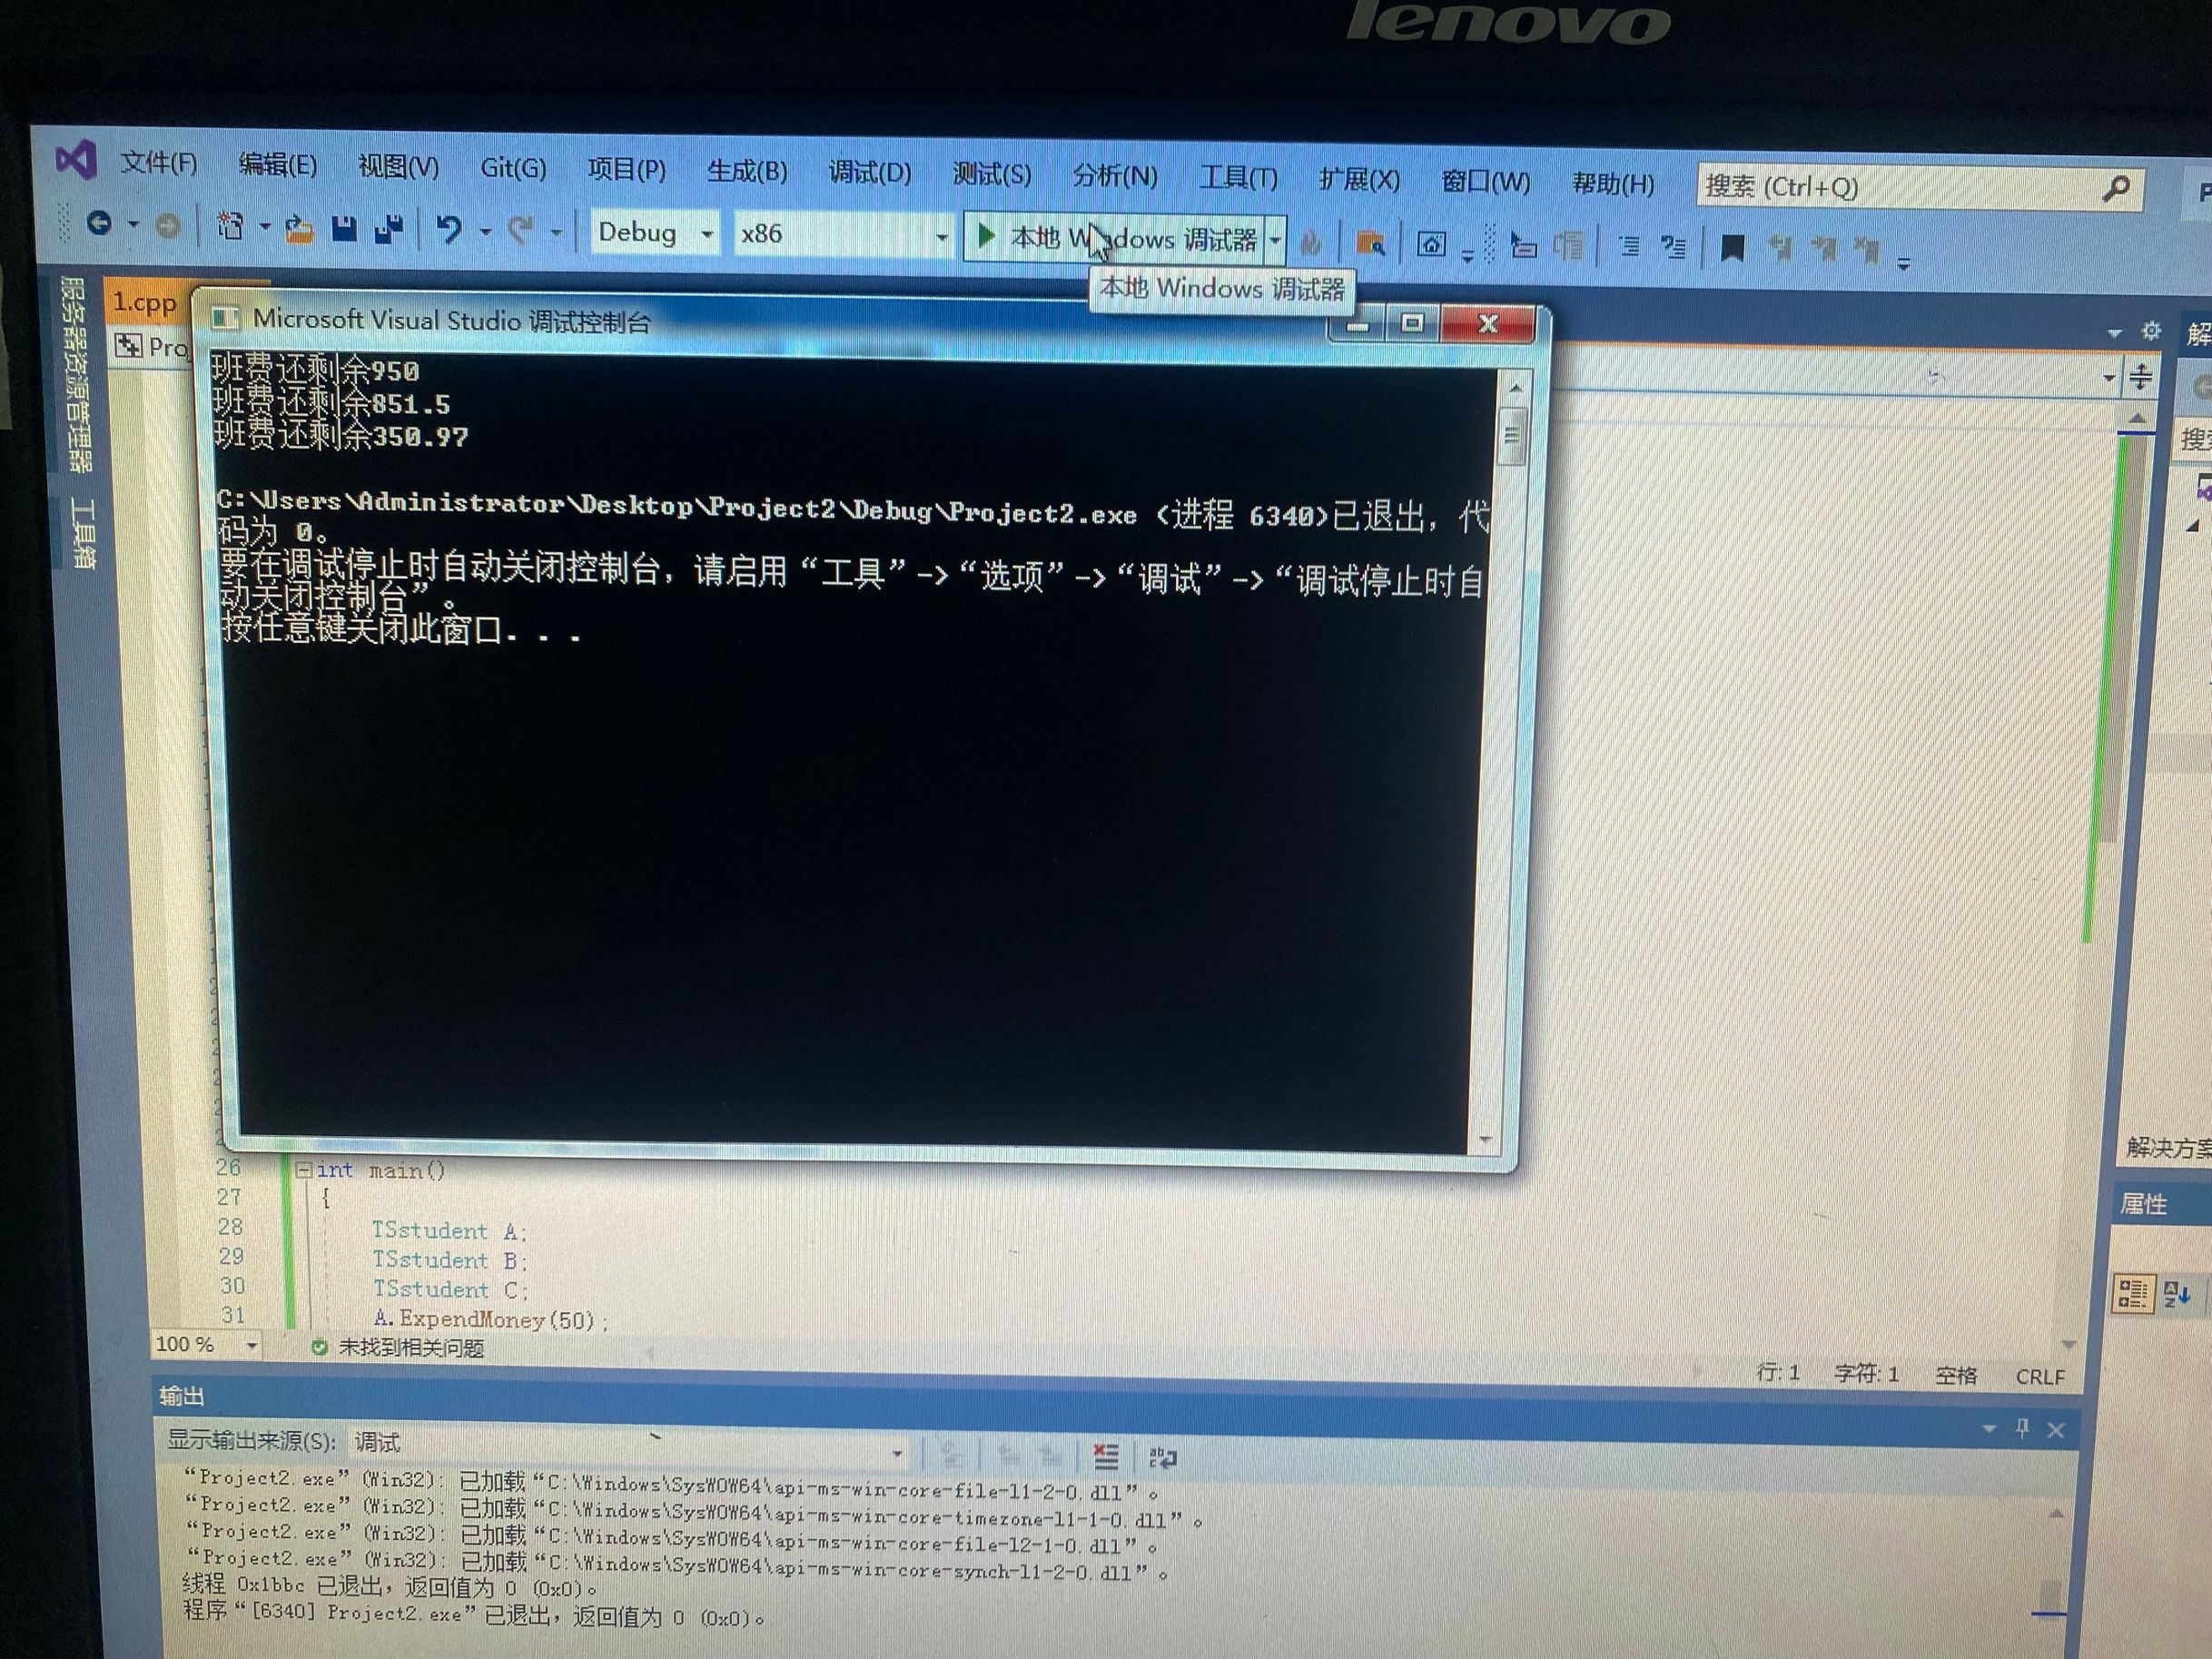
感想心得：本题基类为TSstudent，在类中写了静态成员以及三个成员函数，均为公有的。静态成员赋值要在类外进行初始化。主函数中定义了三个对象，通过对象调用其中的成员函数来计算剩余的钱数。
Copyright ©2021-2099 PengYuRen. All rights reserved

